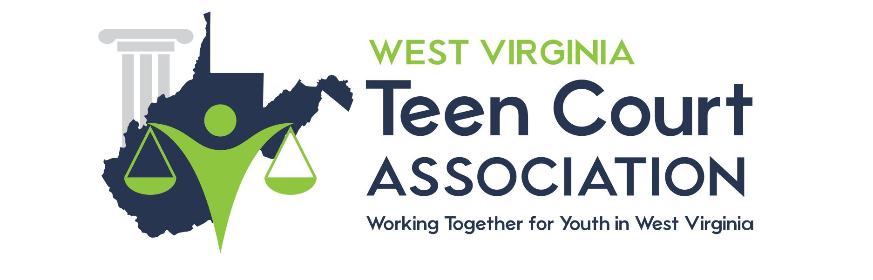

DRUG TESTING INFORMATION

Dear Parents and/or Guardians,

If you have concerns about your child’s possible use of drugs, you may want to exercise your right to have your child tested. The ((health_dept_name)) provides a testing program. The cost is ((cost_amount)) per drug test type (including alcohol, methamphetamines, LSD, cocaine, barbiturates). Studies show that early intervention is important for successful drug treatment. Should the test provide a positive result, you may contact the WV Teen Court office for assistance.

The ((health_dept_name)) laboratory is located at ((address). Their hours are ((hours_dates_and_times)). No appointment is necessary for dropping off the test samples. The child will need to provide a urine sample in a small clean container with their name on it. A urine sample collected in the early morning is best. The sample can be stored in the refrigerator for up to 24 hours and still provide accurate results. Fill out the “Abused Drug Screen” form and turn it in with the sample. The results are confidential and can be mailed to you.

Sincerely,

WV Teen Court Coordinator

