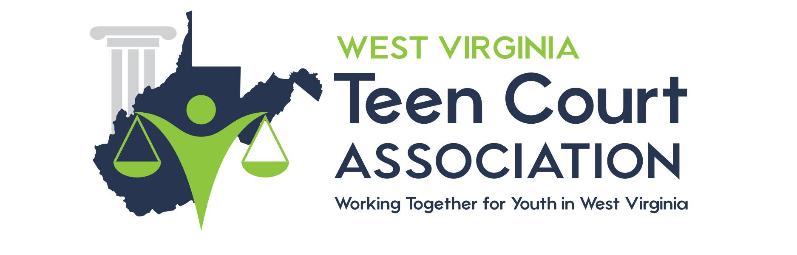

DRESS CODE

All attorneys, clerks, bailiffs and Teen Court Board members must abide by the following dress code established by the Teen Court Board of Directors. Plan ahead if you are coming from a sport or school function and dress accordingly. The dress code will be enforced.

MEN

ACCEPTABLE

Suits
Shirts with collars
Buttoned shirts
Polo shirts
Peer Court shirts
Slacks
Khakis
Sweaters

UNACCEPTABLE

Blue Jeans
Shorts
Tee shirts
Flip flops/ thongs
Undershirts
Baggy pants

WOMEN

ACCEPTABLE

Suits
Dresses
Skirts
Blouses
Peer Court Shirts
Slacks
Khakis
Sweaters

UNACCEPTABLE

Blue Jeans
Shorts
Tee shirts
Flip-flops/ thongs
Spaghetti straps
Exposed midriffs
Revealing tops
Skirts 3 inches higher than the knee
Excessive jewelry
Excessive makeup

